Level 17 -> Level 18

The goal of this level is to find out the different (changed line) between two files named as **passwords.old and passwords.new** present in home directory. And the password is the only line that is changed in passwords.new file.

**Diff** command is very useful here. diff stands for **difference**. This command is used to display the differences in the files by comparing the files line by line.

So, we used the command used is: **diff passwords.new passwords.old**

**In result:**

* Lines preceded by a **<** are lines from the first file.
* Lines preceded by **>** are lines from the second file.
* **42c42** means line 42 in the first file needs to be changed to match line number 42 in the second file.

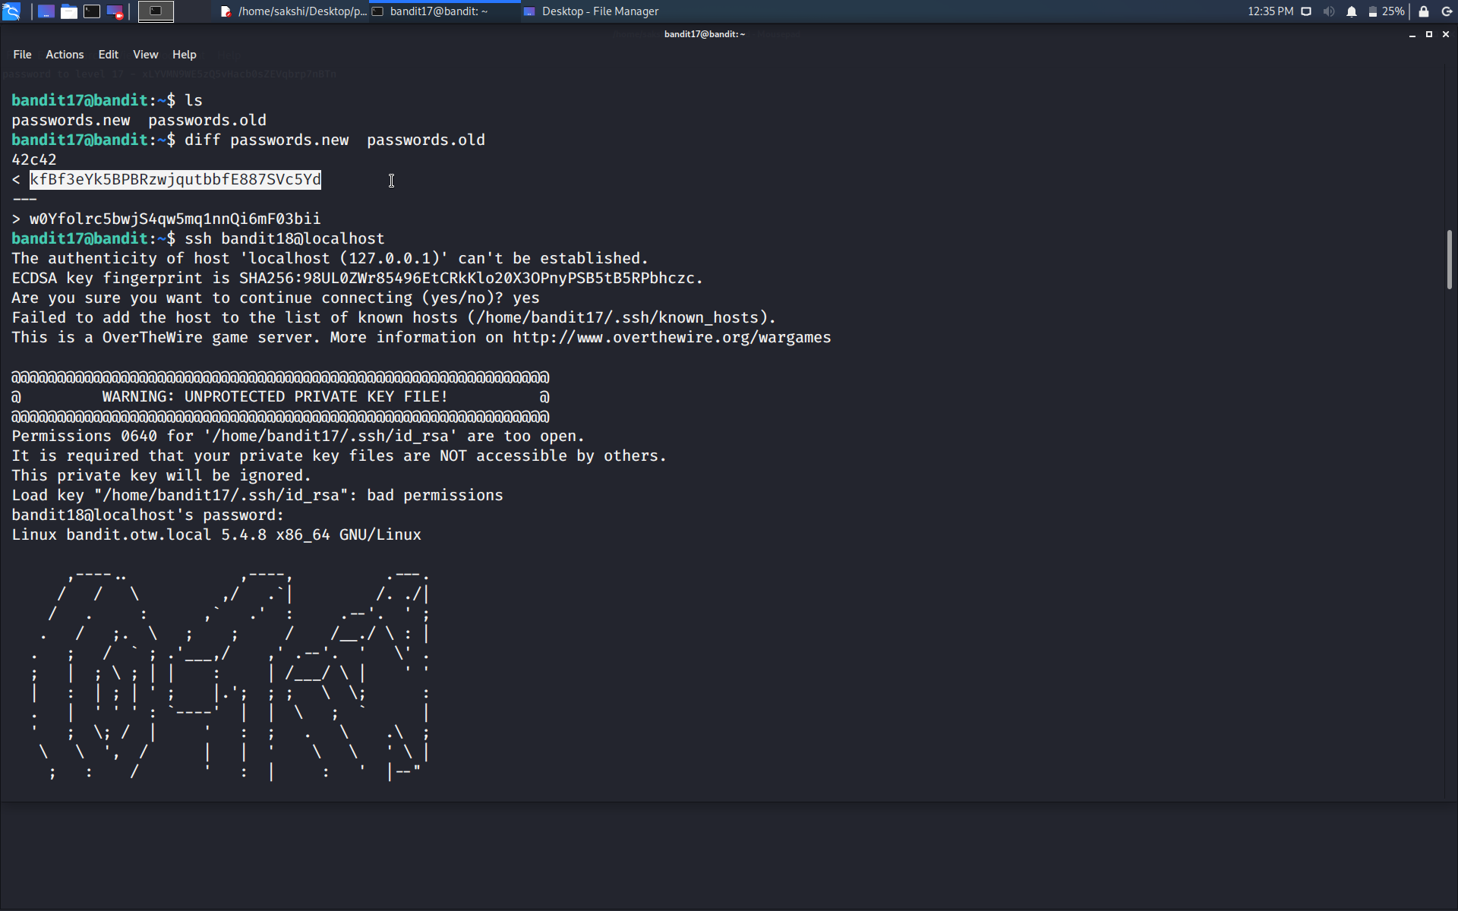

Our password is in file passwords.new. So, line preceded with < is our required password.

Use the command **ssh bandit18@localhost** to connect to the level 18.

Enter the password and hit enter.

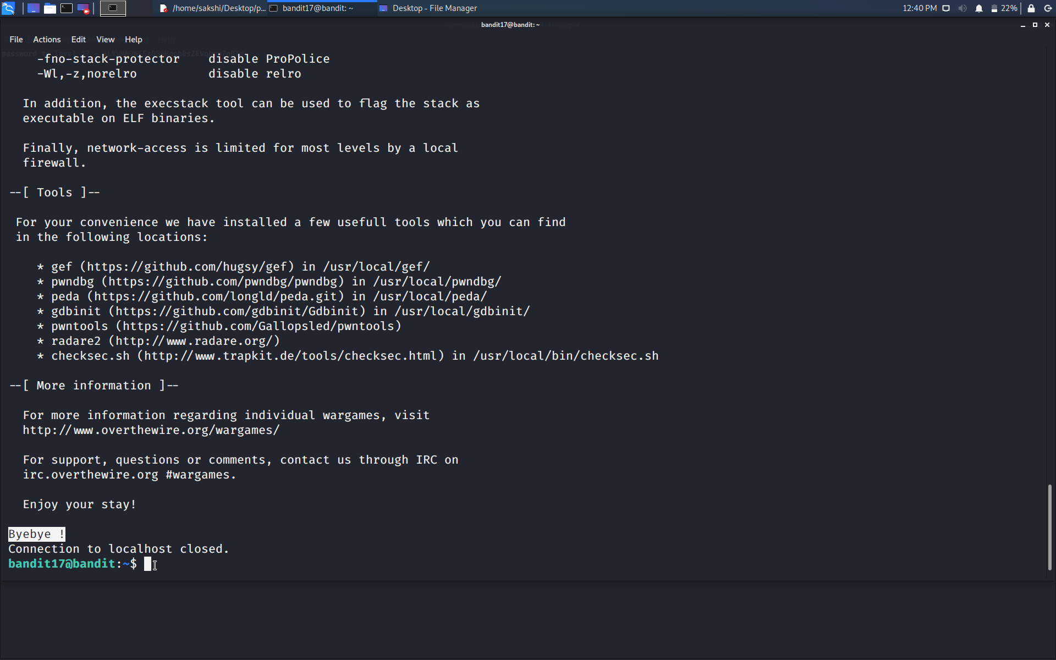

OOPS!!!!! As soon as we try to connect to level 18 connection to the localhost get closed. Reason for this is in level 19.

Save the password of level 18…

